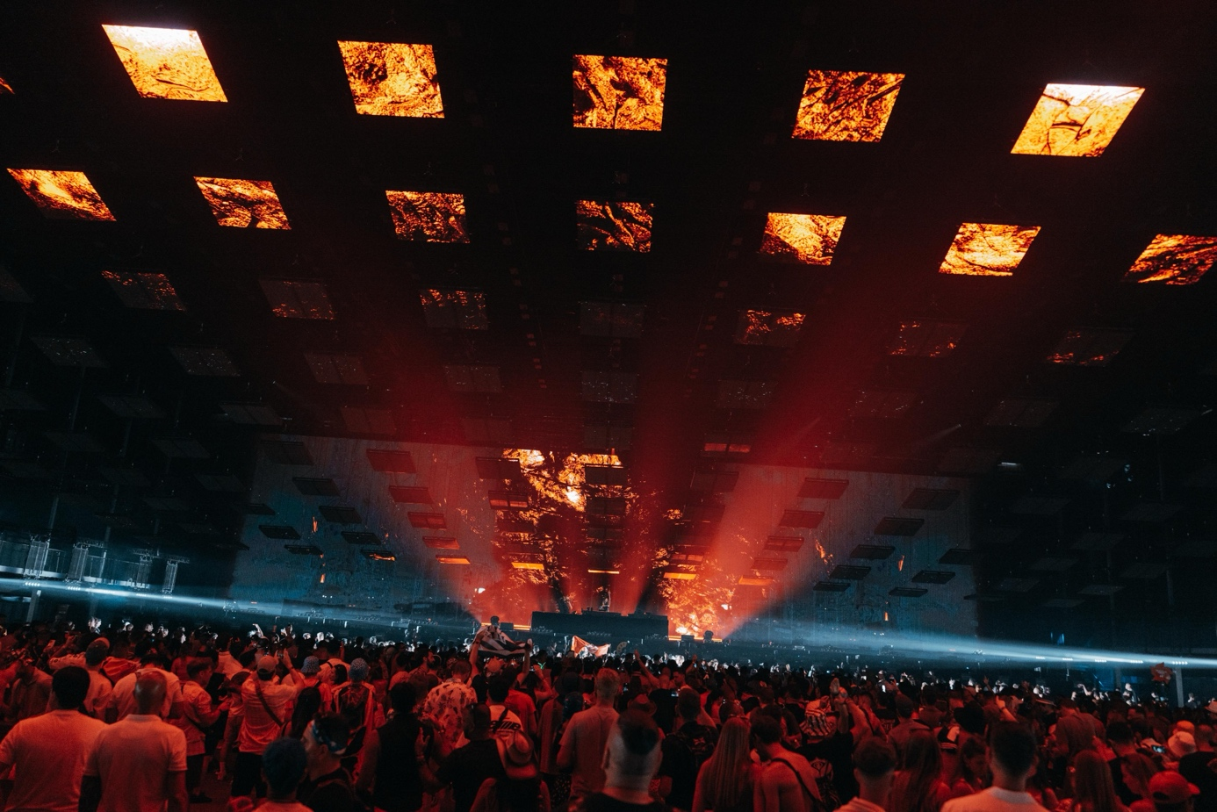
NEO fx at Tomorrowland 2025 – Elevating the Freedom Stage Experience

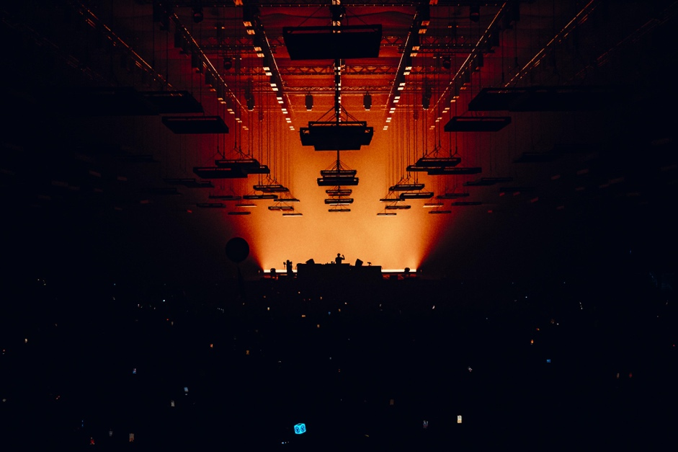
Tomorrowland is more than a festival – it is a masterpiece of music, light, technology, and emotions. In 2025, the Freedom Stage was completely redesigned, centered around a major tech upgrade that turned it into a true marvel of stage engineering.
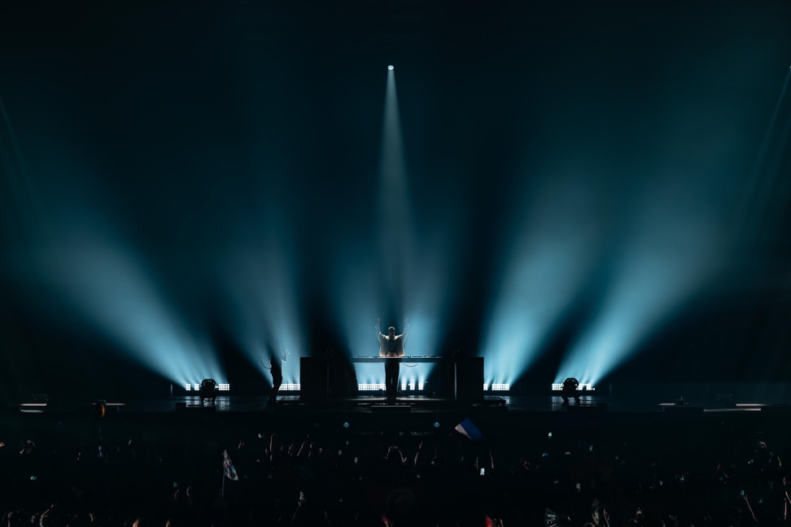
As the world’s largest indoor dancefloor at a festival, the Freedom Stage is crowned by the spectacular Floating Skyinstallation – a kinetic roof and wall system featuring 210 video tiles and 300 m² of LED screens. With a 7-meter moving structure shifting and transforming above the crowd, this venue delivers a club-like intimacy combined with the scale of a festival.
In this high-tech environment, our NEO fx fixtures played a vital role. A total of 20 NEO fx were integrated directly behind the DJ booth on the ground, giving designers a powerful creative toolset:
- Blinder effects that amplified the energy of the drops.
- Precise strobe moments that synced seamlessly with visuals and sound.
- Ambient backlight that extended the depth and impact of the massive LED installation.
“Positioned right behind the DJ, the NEO fx gave us an incredibly strong layer of light that cut through the visuals. They brought energy and precision exactly where it was needed.”
– Paco Mispelters, Senior Producer, Tomorrowland
“Tomorrowland’s Freedom Stage is a showcase of how technology can create emotions on a massive scale. With the NEO fx, we were able to contribute lighting that didn’t just illuminate the stage, but became part of the storytelling.”
– Michael Staffopoulos, Global Business Manager, ROXX
The NEO fx didn’t just add light — they became part of the Freedom Stage’s immersive storytelling, interacting with music and kinetic LED structures to create goosebump-inducing moments for thousands of ravers.

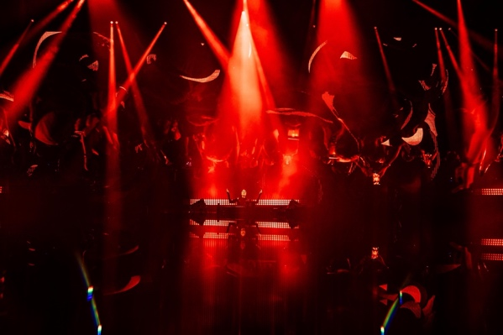
Initially, plans for the main stage also included 200 NEOs from the NEO Series, intended to deliver an exceptional scale of visual impact. However, circumstances beyond control prevented their appearance, leaving the festival’s main stage without them.
We are grateful to the creative and technical teams of Tomorrowland for trusting ROXX to be part of this groundbreaking stage design. For us, the Freedom Stage demonstrates what is possible when cutting-edge technology, creative vision, and emotional impact come together.
👉 Learn more about the NEO fx:

